Interface Requirement Specification

TV Connected _ TDAL_VBI_Slicer

Iwedia

Version V1.0, 2008-10-09

Author: Benoit LE BASSE

Evolutions
Version | Date | Status | Comment
V0.1 | 2008-09-01 | DRAFT | BLE _ First draft
V0.2 | 2008-09-10 | DRAFT | BLE _ Second draft : Change the input enum to use tdal_ana_input input handle
V0.3 | 2008-10-09 | DRAFT | BLE _ Third draft after review
V1.0 | 2008-10-15 | RELEASE | BLE
V1.1 | 2009-09-10 | RELEASE | PPO: add client id parameter for enable and disable slicing

SUMMARY

1 INTRODUCTION 5
1.1 REFERENCE DOCUMENTS 5
1.2 DEFINITIONS, ACRONYMS AND ABBREVIATIONS 5
1.3 OVERVIEW 5
2 TDAL_VBI_Slicer DESCRIPTION 6
2.1 DESCRIPTION 6
2.1.1 General 6
2.1.2 Location of VBI data lines 6
2.1.3 Location of information in VBI data lines 8
2.2 STATIC DIAGRAM 9
2.2.1 Supported features 9
2.2.2 Unsupported features 9
2.2.3 API functions description 10
2.2.3.1 Generic part 10
2.2.3.2 Client Interface part 10
2.2.3.3 Input Interface part 10
2.2.3.4 Interface definition 10
2.2.3.5 Type Specifications 11
2.2.4 External dependencies list 11
2.2.5 Memory consumption and performance 11
3 TDAL_VBI_SLICER DYNAMIC BEHAVIOUR 12
3.1 Interface initialisation, registration, and termination 12
3.2 Data slicing on a particular input 13
4 TDAL_VBI_SLICER API SPECIFICATION 14
4.1 MACRO/DEFINE/ENUM/TYPEDEF/STRUCTURE/UNION DEFINITIONS 14
4.1.1 Define Definitions 14
4.1.1.1 kTDAL_VBI_SLICER_MAX_CLIENT 14
4.1.1.2 kTDAL_VBI_SLICER_ILLEGAL_CLIENT_ID 14
4.1.2 Enum Definitions 15
4.1.2.1 tTDAL_VBI_SLICER_Error 15
4.1.2.2 tTDAL_VBI_SLICER_Standard 15
4.1.2.3 tTDAL_VBI_SLICER_DataType 15
4.1.3 Structure Definitions 16
4.1.3.1 tTDAL_VBI_SLICER_Capability 16
4.1.4 Union Definitions 16
4.1.5 Typedef Definitions 17
4.1.5.1 tTDAL_VBI_SLICER_ClientId 17
4.1.5.2 tTDAL_VBI_SLICER_CallbackWST 17
4.1.5.3 tTDAL_VBI_SLICER_CallbackWSS 18
4.1.5.4 tTDAL_VBI_SLICER_CallbackVPS 19
4.2 API FUNCTIONS 20
4.2.1 Generic API 20
4.2.1.1 TDAL_VBI_SLICER_Init(-) 20
4.2.1.2 TDAL_VBI_SLICER_Term(-) 21
4.2.1.3 TDAL_VBI_SLICER_CapabilityGet(-) 22
4.2.1.4 TDAL_VBI_SLICER_APIRevisionGet(-) 23
4.2.1.5 TDAL_VBI_SLICER_PlatformRevisionGet(-) 24
4.2.2 Client Interface API 25
4.2.2.1 TDAL_VBI_SLICER_ClientRegister(-) 25
4.2.2.2 TDAL_VBI_SLICER_ClientUnregister(-) 26
4.2.2.3 TDAL_VBI_SLICER_ClientRegisterWSTCallback(-) 27
4.2.2.4 TDAL_VBI_SLICER_ClientUnregisterWSTCallback(-) 28
4.2.2.5 TDAL_VBI_SLICER_ClientRegisterVPSCallback(-) 29
4.2.2.6 TDAL_VBI_SLICER_ClientUnregisterVPSCallback(-) 30
4.2.2.7 TDAL_VBI_SLICER_ClientRegisterWSSCallback(-) 31
4.2.2.8 TDAL_VBI_SLICER_ClientUnregisterWSSCallback(-) 32
4.2.2.9 TDAL_VBI_SLICER_ConfigureClientInput(-) 33
4.2.3 Input Interface API 34
4.2.3.1 TDAL_VBI_SLICER_EnableInputSlicing(-) 34
4.2.3.2 TDAL_VBI_SLICER_DisableInputSlicing(-) 35
4.2.3.3 TDAL_VBI_SLICER_Free(-) 36

- INTRODUCTION

  - REFERENCE DOCUMENTS
The following documents were used to write this specification:

Document | Version
EN 300 294 : 625 line WSS (1998-04) | V 1.3.2
ETSI 300 231 : Television systems; Specification of the domestic video Programme Delivery Control system (PDC) | April 1998
ETS 300 708 : Television systems; Data transmission within Teletext | March 1997
TS 101 231 : Television systems; Register of Country and Network Identification (CNI), Video Programming System (VPS) codes and Application codes for Teletext based systems | Version 1.3.1  December 2012

  - DEFINITIONS, ACRONYMS AND ABBREVIATIONS
VBI Vertical Blanking Interface
WSS Wide Screen Signalling
WST World Standard Teletext
VPS Vide Programming System
PAL Phase Alternate Line
SECAM SÉquentiel Couleur À Mémoire
NTSC National Television System Committee
CC Closed Caption
CGMS Copy Generation Management System
PDC Program Delivery Control System

  - OVERVIEW
The purpose of this document is to specify the abstraction layer targeted to manage the slicing of VBI data from an analog video source and the notification to different clients of the presence of incoming data, if matching their requirement.

This module is responsible to provide an unified access to the data extracted from VBI ancillary data.

TDAL_VBI_Slicer is also responsible to extract RAW teletext data from video analog input for injection in a TELETEXT decoder.
- TDAL_VBI_Slicer DESCRIPTION

  - DESCRIPTION
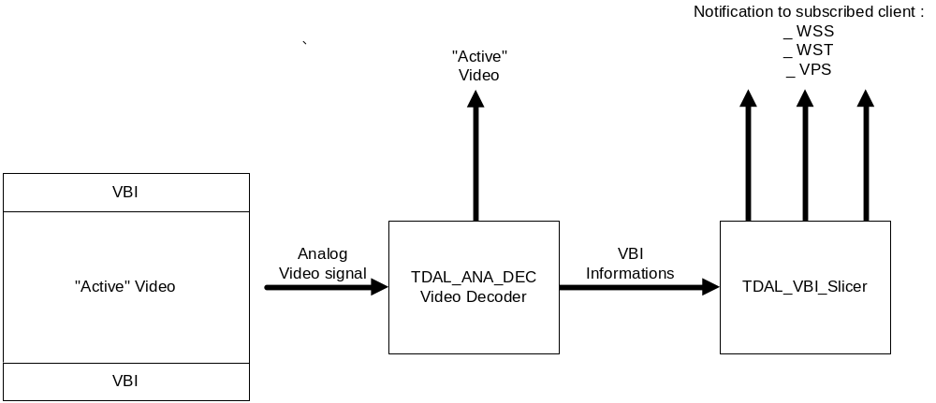
    - General

In analog television systems, the vertical blanking interval can be used to carry digital data. The VBI, also known as VBLANK, is the difference between, the last line of a frame or field, and the beginning if the next one. During the VBI, the incoming data stream is not displayed on the screen.

Several kinds of data can be inserted in the VBI :
_ Teletext
_ WSS
_ Close caption (NTSC)
_ VPS
_ Gemstar information
_ CGMS

Note also, that the macrovision copy protection scheme can also inserted in the VBI as a pulse, not as a data like CGMS or VPS.

    - Location of VBI data lines

In function of the analog video input standard, the VBI data line location is different:

PAL/SECAM

The PAL/SECAM format specify that 625 horizontal lines will be scanned on the TV picture (through only 576 are active line), with a frame refresh rate of 50 Hz. . For the VBI, it is also specifying that 50 horizontal lines (from the 625) will be VBI lines.

VBI data lines are located between lines 6 through 23, and lines 318 through 335.

NTSC

The NTSC format specify that 525 horizontal lines will be scanned on the TV picture (through only 486 are active line), with a frame refresh rate of 60 Hz. For the VBI, it is also specifying that 40 horizontal lines (from the 525) will be VBI lines.

VBI data lines are located between lines 10 through 25, and lines 273 through 288.

Note that both standards are interlaced; it means that data can be found inside odd and even frames.

    - Location of information in VBI data lines

VBI Data | Standard | Line Number | Size | Rely to specification
Teletext WST | PAL-SECAM | 6-22 (6-23 SECAM) & 318-335 | 42 bytes / lines | ETS 300 706
WSS | PAL-SECAM | 23 | 14 bits / lines | EN 300 294
VPS | PAL | 16 | 13 bytes / lines | ETS 300 231
 | NTSC | unsupported

  - STATIC DIAGRAM

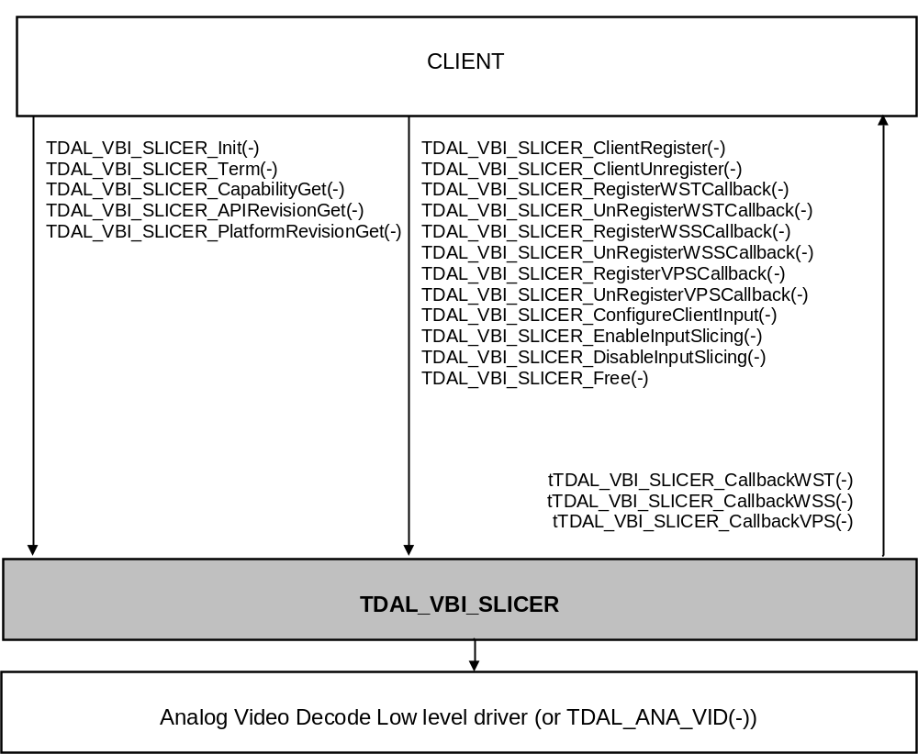

    - Supported features
The module is designed to support the following kind of incoming data:
_ VPS
_ WST
_ WSS

The VBI signal is able to come from one of the following kind of input:
_ Analog broadcast Terrestrial
_ Analog broadcast Cable
_ Other analog inputs can be also implemented (VGA signal …)

The input can be configured for the following format:
_ PAL
_ SECAM

    - Unsupported features
The module is not designed to support the following kind of data:
_ Close Caption
_ Gemstar information
_ CGMS

_ Macrovision signal

The input can not be configured for the following format:
_ NTSC

    - API functions description

      - Generic part
The generic interface allows clients to control the TDAL_VBI_SLICER module.
This interface is used with the following functions:
- TDAL_VBI_SLICER_Init(-) in order to initialise the TDAL_VBI_SLICER module.
- TDAL_VBI_SLICER_Terminate(-) in order to terminate the TDAL_VBI_SLICER module.
- TDAL_VBI_SLICER_CapabilityGet(-) in order to get the capabilities of the current implementation of TDAL_VBI_SLICER module.
- TDAL_VBI_SLICER_APIRevisionGet(-) in order to retrieve the version of the TDAL_VBI_SLICER API.
- TDAL_VBI_SLICER_PlatformRevisionGet(-) in order to retrieve the version of the TDAL_VBI_SLICER platform implementation.

      - Client Interface part
The client interface part allows clients to register to the TDAL_VBI_SLICER module.
This interface is used with the following functions:
- TDAL_VBI_SLICER_ClientRegister(-) in order to register a new client to TDAL_VBI_SLICER
- TDAL_VBI_SLICER_ClientUnRegister (-) in order to unregister a client from TDAL_VBI_SLICER interface
- TDAL_VBI_SLICER_RegisterWSTCallback(-) in order to register a callback to get WST data from analog input
- TDAL_VBI_SLICER_UnregisterWSTCallback(-) in order to unregister a WST callback previously registered
- TDAL_VBI_SLICER_RegisterVPSCallback(-) in order to register a callback to get VPS data from analog input
- TDAL_VBI_SLICER_UnregisterVPSCallback(-) in order to unregister a VPS callback previously registered
- TDAL_VBI_SLICER_RegisterWSSCallback(-) in order to register a callback to get WSS data from analog input
- TDAL_VBI_SLICER_UnregisterWSSCallback (-) in order to unregister a WSS callback previously registered
- TDAL_VBI_SLICER_ConfigureClientInput(-) in order to associate a client to an input

      - Input Interface part
The input interface allows clients to control the input of the TDAL_VBI_SLICER module.
This interface is used with the following functions:
- TDAL_VBI_SLICER_EnableInputSlicing (-) in order to start the slicing on a specific input
- TDAL_VBI_SLICER_DisableInputSlicing (-) in order to stop the slicing on a specific input

      - Interface definition
None
      - Type Specifications
The following definitions are defined for this module
- tTDAL_VBI_SLICER_Error : enum used to identify an error of the TDAL_VBI_SLICER interface
- tTDAL_VBI_SLICER_Capability : structure which defined the capabilities of the TDAL_VBI_SLICER interface (number and kind of inputs, slicing capabilities)
- tTDAL_VBI_SLICER_ClientId defines the client identification type
- tTDAL_VBI_SLICER_CallbackWST defines the prototype of the callback function used to get WST data
- tTDAL_VBI_SLICER_CallbackWSS defines the prototype of the callback function used to get WSS data
- tTDAL_VBI_SLICER_CallbackVPS defines the prototype of the callback function used to get VPS data
- tTDAL_VBI_SLICER_Input : enum which defines the input to be sliced
    - External dependencies list
TDAL_VBI_SLICER needs to associate a client to an analog input stream to get the VBI data.
For that purpose, TDAL_VBI_Slicer is using the input handle defined by the TDAL_ANA_INPUT. The input handle is an unique opaque value that is used as accessor to a specific decoder. See [TDAL_ANA_VID] for further explanation.

    - Memory consumption and performance
Buffers of data are allocated by TDAL_VBI_Slicer module.
Buffers of data shared with clients must be freed by client by using the TDAL_VBI_Slicer_Free(-) function.
- TDAL_VBI_SLICER DYNAMIC BEHAVIOUR

  - Interface initialisation, registration, and termination

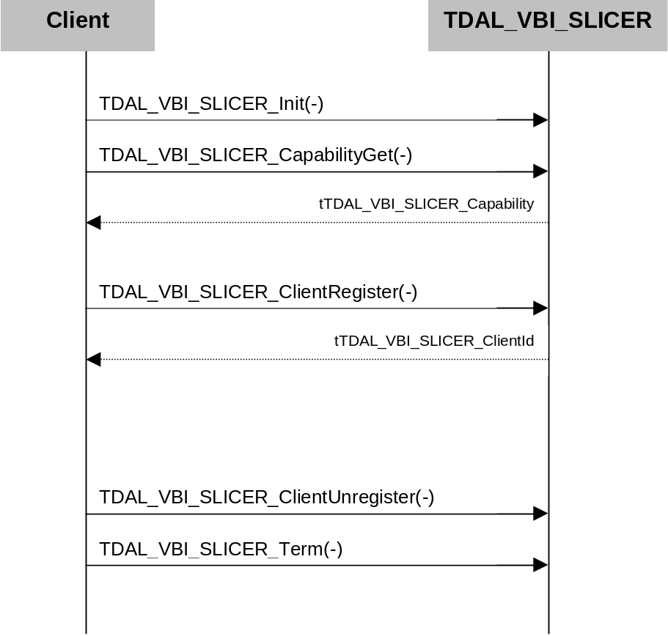

  - Data slicing on a particular input

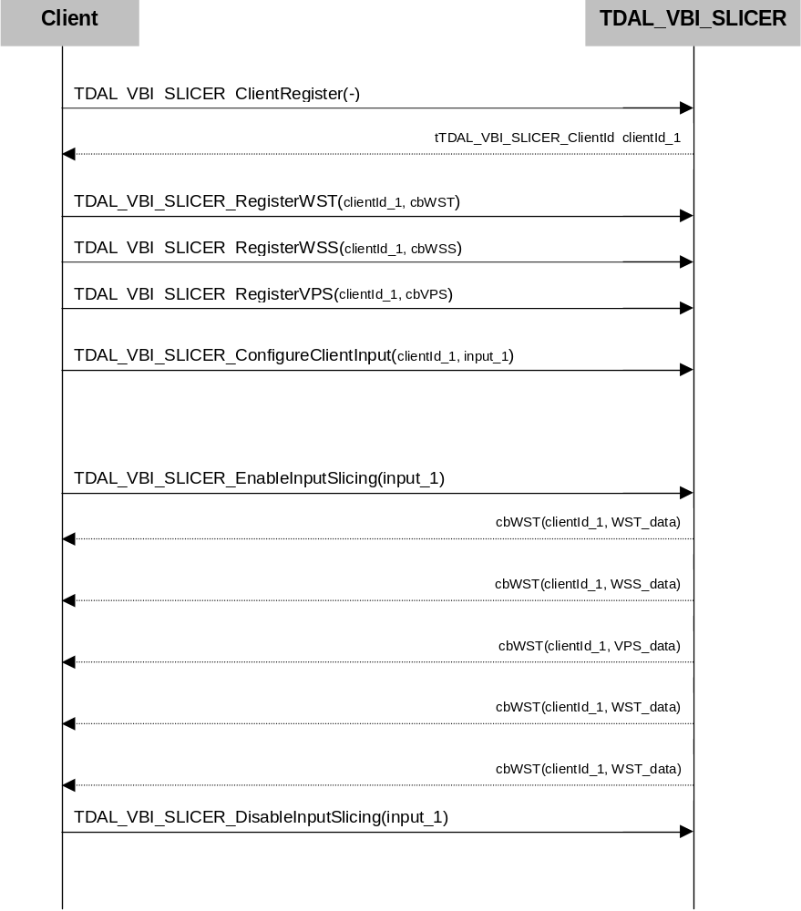
- TDAL_VBI_SLICER API SPECIFICATION

  - MACRO/DEFINE/ENUM/TYPEDEF/STRUCTURE/UNION DEFINITIONS

    - Define Definitions

      - kTDAL_VBI_SLICER_MAX_CLIENT

This constant is used to define the maximum number of client allowed.

#define kTDAL_VBI_SLICER_MAX_CLIENT 4

      - kTDAL_VBI_SLICER_ILLEGAL_CLIENT_ID

This constant is used to identify an illegal client id.

#define kTDAL_VBI_SLICER_ILLEGAL_CLIENT_ID -1

    - Enum Definitions

      - tTDAL_VBI_SLICER_Error
An enumeration of the different possible errors generated by TDAL_VBI_SLICER module.
typedef enum
{
eTDAL_VBI_SLICER_NO_ERROR, /* No Error returned */
eTDAL_VBI_SLICER_NOT_INIT_ERROR, /* TDAL_VBI_SLICER not initialised */
eTDAL_VBI_SLICER_ALREADY_INIT_ERROR, /* TDAL_VBI_SLICER already initialised */
eTDAL_VBI_SLICER_BAD_ARG_ERROR, /* Bad parameter given to the function */
eTDAL_VBI_SLICER_DRIVER_ERROR, /* Low level driver returns an error */
eTDAL_VBI_SLICER_NO_MEMORY_ERROR, /* Not enough memory to perform action*/
eTDAL_VBI_SLICER_NOT_AVAILABLE_ERROR /* Feature not available*/
}tTDAL_VBI_SLICER_Error;

      - tTDAL_VBI_SLICER_Standard
An enumeration of the different possible format managed by TDAL_VBI_SLICER module.
typedef enum
{
eTDAL_VBI_SLICER_STANDARD_PAL = 0x00000001,
eTDAL_VBI_SLICER_STANDARD_SECAM = 0x00000002,
eTDAL_VBI_SLICER_STANDARD_NTSC = 0x00000004
}tTDAL_VBI_SLICER_Standard;

      - tTDAL_VBI_SLICER_DataType
An enumeration of the different possible data type managed by TDAL_VBI_SLICER module.
typedef enum
{
eTDAL_VBI_SLICER_DATA_VPS = 0x00000001,
eTDAL_VBI_SLICER_DATA_WST = 0x00000002,
eTDAL_VBI_SLICER_DATA_WSS = 0x00000004
} tTDAL_VBI_SLICER_DataType;
    - Structure Definitions

      - tTDAL_VBI_SLICER_Capability
Description:

This structure defines the capabilities of a TDAL_VBI_SLICER implementation.

Definition:

typedef struct TDAL_VBI_SLICER_Capability_s
{
uint32_t StandardSupportedBitmask;
uint32_t DataTypeSupportedBitmask;
} tTDAL_VBI_SLICER_Capability;

Elements:

Field | Type | Description
StandardSupportedBitmask | uint32_t | Standard supported bitmask
DataTypeSupportedBitmask | uint32_t | Data type supported bitmask

Comments:

None.

See Also:

tTDAL_VBI_SLICER_Standard
tTDAL_VBI_SLICER_DataType
TDAL_VBI_SLICER_CapabilityGet(-)

    - Union Definitions

None
    - Typedef Definitions

      - tTDAL_VBI_SLICER_ClientId
This typed defines a client object.

typedef int32_t tTDAL_VBI_SLICER_ClientId;

      - tTDAL_VBI_SLICER_CallbackWST
This typedef defines the notification WST callback function prototype registered to TDAL_VBI_SLICER:

Prototype:

typedef void (*tTDAL_VBI_SLICER_CallbackWST)
(
tTDAL_VBI_SLICER_ClientId stClientId,
uint32_t ulInputHandle,
uint16_t usSizeOfData,
const void *pData
);

Return value:

None.

Parameters:

Parameter | Type | Dir | Description
stClientId | tTDAL_VBI_SLICER_ClientId | In | Decoder identifier on which event occurs.
ulInputHandle | uint32_t | In | Input handle
usSizeOfData | uint16_t | In | Size of data pointed by pData
pData | const void * | In | Pointer to data related to the WST, or a NULL pointer if there is no data.

Comments:

The size of a WST frame is variable.

See Also:
tTDAL_VBI_SLICER_ClientId
TDAL_VBI_SLICER_ClientRegisterWSTCallback(-)
TDAL_VBI_SLICER_ClientUnregisterWSTCallback(-)
TDAL_VBI_SLICER_Free(-)

      - tTDAL_VBI_SLICER_CallbackWSS
This typedef defines the notification WSS callback function prototype registered to TDAL_VBI_SLICER:

Prototype:

typedef void (*tTDAL_VBI_SLICER_CallbackWSS)
(
tTDAL_VBI_SLICER_ClientId stClientId,
uint32_t ulInputHandle,
uint16_t usSizeOfData,
const void *pData
);

Return value:

None.

Parameters:

Parameter | Type | Dir | Description
stClientId | tTDAL_VBI_SLICER_ClientId | In | Decoder identifier on which event occurs.
ulInputHandle | uint32_t | In | Input handle
usSizeOfData | uint16_t | In | Size of data pointed by pData
pData | const void * | In | Pointer to data related to the WSS, or a NULL pointer if there is no data.

Comments:

The size of a WSS frame is fixed to 14 bits.

See Also:
tTDAL_VBI_SLICER_ClientId
TDAL_VBI_SLICER_ClientRegisterWSSCallback(-)
TDAL_VBI_SLICER_ClientUnregisterWSSCallback(-)
TDAL_VBI_SLICER_Free(-)

      - tTDAL_VBI_SLICER_CallbackVPS
This typedef defines the notification VPS callback function prototype registered to TDAL_VBI_SLICER:

Prototype:

typedef void (*tTDAL_VBI_SLICER_CallbackVPS)
(
tTDAL_VBI_SLICER_ClientId stClientId,
uint32_t ulInputHandle,
uint16_t usSizeOfData,
const void *pData
);

Return value:

None.

Parameters:

Parameter | Type | Dir | Description
stClientId | tTDAL_VBI_SLICER_ClientId | In | Decoder identifier on which event occurs.
ulInputHandle | uint32_t | In | Input handle
usSizeOfData | uint16_t | In | Size of data pointed by pData
pData | const void * | In | Pointer to data related to the VPS, or a NULL pointer if there is no data.

Comments:

The size of a VPS frame is fixed to 13 bits.

See Also:
tTDAL_VBI_SLICER_ClientId
TDAL_VBI_SLICER_ClientRegisterVPSCallback(-)
TDAL_VBI_SLICER_ClientUnregisterVPSCallback(-)
TDAL_VBI_SLICER_Free(-)
  - API FUNCTIONS

    - Generic API

      - TDAL_VBI_SLICER_Init(-)
Prototype:

tTDAL_VBI_SLICER_Error TDAL_VBI_SLICER_Init (void);

Description:

This function initialises the TDAL_VBI_SLICER module.

Return value:

It returns eTDAL_VBI_SLICER_NO_ERROR if initialization succeed.
It returns eTDAL_VBI_SLICER_ALREADY_INIT_ERROR if TDAL_VBI_SLICER module already initialized.
It returns eTDAL_VBI_SLICER_DRIVER_ERROR if an error occurs in low level driver.
It returns eTDAL_VBI_SLICER_NO_MEMORY_ERROR if not enough memory to initialize.

Parameters:

None.

Comments:

This function must be called before any other functions of the TDAL_VBI_SLICER API.

See Also:
tTDAL_VBI_SLICER_Error
TDAL_VBI_SLICER_Term(-)
      - TDAL_VBI_SLICER_Term(-)
Prototype:

tTDAL_VBI_SLICER_Error TDAL_VBI_SLICER_Term (void);

Description:

This function terminates the TDAL_VBI_SLICER module. This function stop all previous slicing work in progress, free the low level resources, free the memory and the OS resources.

Return value:

It returns eTDAL_VBI_SLICER_NO_ERROR if termination succeed.
It returns eTDAL_VBI_SLICER_NOT_INIT_ERROR if TDAL_VBI_SLICER not initialized.
It returns eTDAL_VBI_SLICER_DRIVER_ERROR if an error occurs in low level driver.

Parameters:

None.

Comments:

Any function of TDAL_VBI_SLICER API should not be called after TDAL_VBI_SLICER_Term(-) call.

See Also:
tTDAL_VBI_SLICER_Error
TDAL_VBI_SLICER_Init(-)
      - TDAL_VBI_SLICER_CapabilityGet(-)
Prototype:

tTDAL_VBI_SLICER_Error TDAL_VBI_SLICER_CapabilityGet
(
tTDAL_VBI_SLICER_Capability *pstCapability
);

Description:

This function retrieves the capabilities of the TDAL_VBI_SLICER current implementation.

Return value:

It returns eTDAL_VBI_SLICER_NO_ERROR if retrieve of capabilities succeed.
It returns eTDAL_VBI_SLICER_NOT_INIT_ERROR if TDAL_VBI_SLICER not initialized.
It returns eTDAL_VBI_SLICER_DRIVER_ERROR if an error occurs in low level driver.
It returns eTDAL_VBI_SLICER_BAD_PARAMETER_ERROR otherwise.

Parameters:

Parameter | Type | Dir | Description
pstCapability | tTDAL_VBI_SLICER_Capability * | In/out | In: Allocated capability structure pointer.  Out: Structure filled with capabilities of the implementation of the TDAL_VBI_SLICER module.

Comments:

This function can be called at any time the TDAL_VBI_SLICER has been initialised with TDAL_VBI_SLICER_Init(-) but not after the termination with TDAL_VBI_SLICER_Term(-).

See Also:
tTDAL_VBI_SLICER_Error
tTDAL_VBI_SLICER_Capability

      - TDAL_VBI_SLICER_APIRevisionGet(-)
Prototype:

const char *TDAL_VBI_SLICER_APIRevisionGet(void);

Description:

This function retrieves the API revision.

Return value:

A string containing the revision of the TDAL_VBI_SLICER API.

Parameters:

None.

Comments:

This function can be called at any time.

See Also:

      - TDAL_VBI_SLICER_PlatformRevisionGet(-)
Prototype:

const char *TDAL_VBI_SLICER_PlatformRevisionGet(void);

Description:

This function retrieves the platform implementation revision.

Return value:

A string containing the revision of the TDAL_VBI_SLICER implementation on a platform.

Parameters:

None.

Comments:

This function can be called at any time.

See Also:

    - Client Interface API

      - TDAL_VBI_SLICER_ClientRegister(-)
Prototype:

tTDAL_VBI_SLICER_Error TDAL_VBI_SLICER_ClientRegister
(
tTDAL_VBI_SLICER_ClientId *pstClientId
);

Description:

This function registers a new client to TDAL_VBI_SLICER module

Return value:

It returns eTDAL_VBI_SLICER_NO_ERROR if client register.
It returns eTDAL_VBI_SLICER_NOT_INIT_ERROR if TDAL_VBI_SLICER not initialised.
It returns eTDAL_VBI_SLICER_BAD_PARAMETER_ERROR if pstClientId not allocated.

Parameters:

Parameter | Type | Dir | Description
pstClientId | tTDAL_VBI_SLICER_ClientId * | In/out | In: Allocated capability structure pointer.  Out: ClientId

Comments:

The TDAL_VBI_Slicer shall be multi client.

See Also:
tTDAL_VBI_SLICER_Error
tTDAL_VBI_SLICER_ClientId
TDAL_VBI_SLICER_ClientUnregister(-)

      - TDAL_VBI_SLICER_ClientUnregister(-)
Prototype:

tTDAL_VBI_SLICER_Error TDAL_VBI_SLICER_ClientUnregister
(
tTDAL_VBI_SLICER_ClientId stClientId
);

Description:

This function unregisters a client to TDAL_VBI_SLICER module

Return value:

It returns eTDAL_VBI_SLICER_NO_ERROR if client unregister successful.
It returns eTDAL_VBI_SLICER_NOT_INIT_ERROR if TDAL_VBI_SLICER not initialized.
It returns eTDAL_VBI_SLICER_BAD_PARAMETER_ERROR if stClientId not known

Parameters:

Parameter | Type | Dir | Description
stClientId | tTDAL_VBI_SLICER_ClientId | In | In: ClientId

Comments:

None

See Also:
tTDAL_VBI_SLICER_Error
tTDAL_VBI_SLICER_ClientId
TDAL_VBI_SLICER_ClientRegister(-)

      - TDAL_VBI_SLICER_ClientRegisterWSTCallback(-)
Prototype:

tTDAL_VBI_SLICER_Error TDAL_VBI_SLICER_ClientRegisterWSTCallback
(
tTDAL_VBI_SLICER_ClientId stClientId,
tTDAL_VBI_SLICER_CallbackWST cbWSTCallback
);

Description:

This function registers the WST callback for a TDAL_VBI_SLICER client

Return value:

It returns eTDAL_VBI_SLICER_NO_ERROR if callback registered successful.
It returns eTDAL_VBI_SLICER_NOT_INIT_ERROR if TDAL_VBI_SLICER not initialized.
It returns eTDAL_VBI_SLICER_BAD_PARAMETER_ERROR if stClientId not known

Parameters:

Parameter | Type | Dir | Description
stClientId | tTDAL_VBI_SLICER_ClientId | In | In: ClientId
cbWSTCallback | tTDAL_VBI_SLICER_CallbackWST | In | In: WST callback

Comments:

None

See Also:
tTDAL_VBI_SLICER_Error
tTDAL_VBI_SLICER_ClientId
tTDAL_VBI_SLICER_CallbackWST
TDAL_VBI_SLICER_ClientUnregisterWSTCallback(-)
      - TDAL_VBI_SLICER_ClientUnregisterWSTCallback(-)
Prototype:

tTDAL_VBI_SLICER_Error TDAL_VBI_SLICER_ClientUnregisterWSTCallback
(
tTDAL_VBI_SLICER_ClientId stClientId
);

Description:

This function unregisters the WST callback associated to a TDAL_VBI_SLICER client

Return value:

It returns eTDAL_VBI_SLICER_NO_ERROR if callback unregistered successful.
It returns eTDAL_VBI_SLICER_NOT_INIT_ERROR if TDAL_VBI_SLICER not initialized.
It returns eTDAL_VBI_SLICER_BAD_PARAMETER_ERROR if stClientId not known

Parameters:

Parameter | Type | Dir | Description
stClientId | tTDAL_VBI_SLICER_ClientId | In | In: ClientId

Comments:

None

See Also:
tTDAL_VBI_SLICER_Error
tTDAL_VBI_SLICER_ClientId
tTDAL_VBI_SLICER_CallbackWST
TDAL_VBI_SLICER_ClientRegisterWSTCallback(-)
      - TDAL_VBI_SLICER_ClientRegisterVPSCallback(-)
Prototype:

tTDAL_VBI_SLICER_Error TDAL_VBI_SLICER_ClientRegisterVPSCallback
(
tTDAL_VBI_SLICER_ClientId stClientId,
tTDAL_VBI_SLICER_CallbackVPS cbVPSCallback
);

Description:

This function registers the VPS callback for a TDAL_VBI_SLICER client

Return value:

It returns eTDAL_VBI_SLICER_NO_ERROR if callback registered successful.
It returns eTDAL_VBI_SLICER_NOT_INIT_ERROR if TDAL_VBI_SLICER not initialized.
It returns eTDAL_VBI_SLICER_BAD_PARAMETER_ERROR if stClientId not known

Parameters:

Parameter | Type | Dir | Description
stClientId | tTDAL_VBI_SLICER_ClientId | In | In: ClientId
cbVPSCallback | tTDAL_VBI_SLICER_CallbackVPS | In | In: VPS callback

Comments:

None

See Also:
tTDAL_VBI_SLICER_Error
tTDAL_VBI_SLICER_ClientId
tTDAL_VBI_SLICER_CallbackVPS
TDAL_VBI_SLICER_ClientUnregisterVPSCallback(-)
      - TDAL_VBI_SLICER_ClientUnregisterVPSCallback(-)
Prototype:

tTDAL_VBI_SLICER_Error TDAL_VBI_SLICER_ClientUnregisterVPSCallback
(
tTDAL_VBI_SLICER_ClientId stClientId
);

Description:

This function unregisters the VPS callback associated to a TDAL_VBI_SLICER client

Return value:

It returns eTDAL_VBI_SLICER_NO_ERROR if callback unregistered successful.
It returns eTDAL_VBI_SLICER_NOT_INIT_ERROR if TDAL_VBI_SLICER not initialized.
It returns eTDAL_VBI_SLICER_BAD_PARAMETER_ERROR if stClientId not known

Parameters:

Parameter | Type | Dir | Description
stClientId | tTDAL_VBI_SLICER_ClientId | In | In: ClientId

Comments:

None

See Also:
tTDAL_VBI_SLICER_Error
tTDAL_VBI_SLICER_ClientId
tTDAL_VBI_SLICER_CallbackVPS
TDAL_VBI_SLICER_ClientRegisterVPSCallback(-)

      - TDAL_VBI_SLICER_ClientRegisterWSSCallback(-)
Prototype:

tTDAL_VBI_SLICER_Error TDAL_VBI_SLICER_ClientRegisterWSSCallback
(
tTDAL_VBI_SLICER_ClientId stClientId,
tTDAL_VBI_SLICER_CallbackWSS cbWSSCallback
);

Description:

This function registers the WSS callback for a TDAL_VBI_SLICER client

Return value:

It returns eTDAL_VBI_SLICER_NO_ERROR if callback registered successful.
It returns eTDAL_VBI_SLICER_NOT_INIT_ERROR if TDAL_VBI_SLICER not initialized.
It returns eTDAL_VBI_SLICER_BAD_PARAMETER_ERROR if stClientId not known

Parameters:

Parameter | Type | Dir | Description
stClientId | tTDAL_VBI_SLICER_ClientId | In | In: ClientId
cbWSSCallback | tTDAL_VBI_SLICER_CallbackWSS | In | In: WSS callback

Comments:

None

See Also:
tTDAL_VBI_SLICER_Error
tTDAL_VBI_SLICER_ClientId
tTDAL_VBI_SLICER_CallbackWSS
TDAL_VBI_SLICER_ClientUnregisterWSSCallback(-)
      - TDAL_VBI_SLICER_ClientUnregisterWSSCallback(-)
Prototype:

tTDAL_VBI_SLICER_Error TDAL_VBI_SLICER_ClientUnregisterWSSCallback
(
tTDAL_VBI_SLICER_ClientId stClientId
);

Description:

This function unregisters the WSS callback associated to a TDAL_VBI_SLICER client

Return value:

It returns eTDAL_VBI_SLICER_NO_ERROR if callback unregistered successful.
It returns eTDAL_VBI_SLICER_NOT_INIT_ERROR if TDAL_VBI_SLICER not initialized.
It returns eTDAL_VBI_SLICER_BAD_PARAMETER_ERROR if stClientId not known

Parameters:

Parameter | Type | Dir | Description
stClientId | tTDAL_VBI_SLICER_ClientId | In | In: ClientId

Comments:

None

See Also:
tTDAL_VBI_SLICER_Error
tTDAL_VBI_SLICER_ClientId
tTDAL_VBI_SLICER_CallbackWSS
TDAL_VBI_SLICER_ClientRegisterWSSCallback(-)
      - TDAL_VBI_SLICER_ConfigureClientInput(-)
Prototype:

tTDAL_VBI_SLICER_Error TDAL_VBI_SLICER_ConfigureClientInput
(
tTDAL_VBI_SLICER_ClientId stClientId,
uint32_t ulInputHandle
);

Description:

This function associates an input to a client previously registered.

Return value:

It returns eTDAL_VBI_SLICER_NO_ERROR if association successful.
It returns eTDAL_VBI_SLICER_NOT_INIT_ERROR if TDAL_VBI_SLICER not initialised.
It returns eTDAL_VBI_SLICER_BAD_PARAMETER_ERROR if stClientId not known or eInput not known

Parameters:

Parameter | Type | Dir | Description
stClientId | tTDAL_VBI_SLICER_ClientId | In | In: ClientId
ulInputHandle | uint32_t | In | In: Input to associate to the clientId
eDataType | tTDAL_VBI_SLICER_DataType | In | In: Data associate to the eInput

Comments:

After registration, a client is not associated to an input and a standard. This call is mandatory to get information (WSS/WST/VPS) from an input.
ulInputHandle is the unique opaque identifier of an analog input See [TDAL_ANA_VID] for further information.

See Also:
tTDAL_VBI_SLICER_Error
tTDAL_VBI_SLICER_ClientId
tTDAL_VBI_SLICER_DataType

    - Input Interface API

      - TDAL_VBI_SLICER_EnableInputSlicing(-)
Prototype:

tTDAL_VBI_SLICER_Error TDAL_VBI_SLICER_EnableInputSlicing
(
tTDAL_VBI_SLICER_ClientId stClientId,
uint32_t ulInputHandle
);

Description:

This function starts the slicing on the given input, for a specific client (the registered callbacks will be called if data are found).

Return value:

It returns eTDAL_VBI_SLICER_NO_ERROR if slicing is started successfully.
It returns eTDAL_VBI_SLICER_NOT_INIT_ERROR if TDAL_VBI_SLICER not initialised.
It returns eTDAL_VBI_SLICER_BAD_PARAMETER_ERROR if input not known
It returns eTDAL_VBI_SLICER_DRIVER_ERROR if slicing not able to be started due to low level layer

Parameters:

Parameter | Type | Dir | Description
stClientId | tTDAL_VBI_SLICER_ClientId | In | Client Id
ulInputHandle | uint32_t | In | In: Input to start

Comments:

The notification of incoming data (WSS/WST/VPS) will occurs only if:
_ a client has been registered and associated to this input
_ WSS/WST/VPS callback has been registered for this client
No need to start the slicing at low level if both conditions are not present.

ulInputHandle is the unique opaque identifier of an analog input See [TDAL_ANA_VID] for further information.

See Also:
tTDAL_VBI_SLICER_Error
TDAL_VBI_SLICER_DisableInputSlicing(-)

      - TDAL_VBI_SLICER_DisableInputSlicing(-)
Prototype:

tTDAL_VBI_SLICER_Error TDAL_VBI_SLICER_DisableInputSlicing
(
tTDAL_VBI_SLICER_ClientId stClientId,
uint32_t ulInputHandle
);

Description:

This function stops the slicing on the given input, for a specific client (the registered callbacks will not be called even if data are found).

Return value:

It returns eTDAL_VBI_SLICER_NO_ERROR if slicing is stopped successfully.
It returns eTDAL_VBI_SLICER_NOT_INIT_ERROR if TDAL_VBI_SLICER not initialised.
It returns eTDAL_VBI_SLICER_BAD_PARAMETER_ERROR if input not known
It returns eTDAL_VBI_SLICER_DRIVER_ERROR if slicing not able to be started due to low level layer

Parameters:

Parameter | Type | Dir | Description
stClientId | tTDAL_VBI_SLICER_ClientId | In | Client Id
ulInputHandle | uint32_t | In | In: Input to stop

Comments:

ulInputHandle is the unique opaque identifier of an analog input See [TDAL_ANA_VID] for further information.

See Also:
tTDAL_VBI_SLICER_Error
TDAL_VBI_SLICER_EnableInputSlicing(-)

      - TDAL_VBI_SLICER_Free(-)
Prototype:

void TDAL_VBI_SLICER_Free
(
void *pData
);

Description:

This function frees a buffer.

Return value:

Void

Parameters:

Parameter | Type | Dir | Description
pData | void * | In | In: Buffer to free

Comments:

None

See Also:

None

